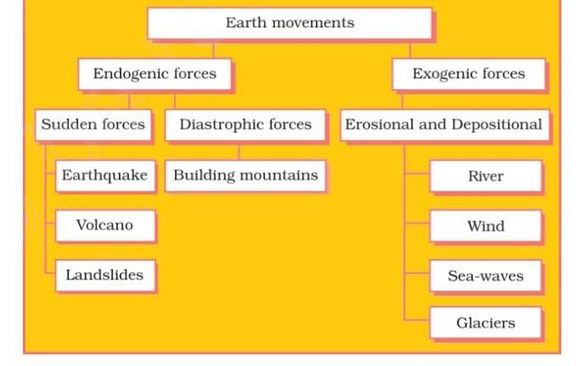

**EVOLUTION OF LANDFORMS**